Candidate Name: | Musa Mashauri Joseph | 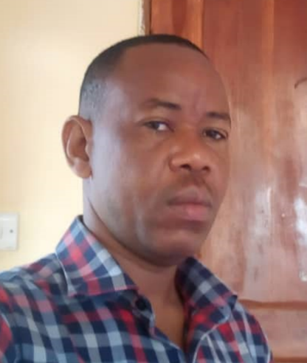
Registration Number: | 2020-07-00127
Institution: | University of Dar es Salaam - School of Education

Qualifications Attained:
Mr. Musa Mashauri Joseph is a PhD candidate by thesis in the Department of Educational Foundations, Management and Lifelong Learning, School of Education, University of Dar es Salaam. He holds a Masters Degree of Education in Administration, Planning, and Policy Studies from the Open University of Tanzania and Bachelor Degree (Bachelor of Arts with Education) from the Saint Augustine University of Tanzania. Also, he holds a Diploma in Education from Butimba Teachers’ College as well as a Grade A Certificate in Education grade “A” at Bunda Teachers’ College. Currently, Mr. Musa is working at Itilima District Council as a District Statistics and Logistic Officer in the Secondary Education Department. His research of interest include; educational policies implementation, management in education and school infrastructure facilities development.

Title of Thesis: | Effectiveness of Management Models in the implementation of Education Policy on Infrastructure Facilities Development in Public Secondary Schools in Mara Region, Tanzania
Date of Viva Voce: | 3rd May, 2024
Venue: | Board Room-SoED
Time: | 10: 00a.m
Supervisors: | Prof. Justinian Galabawa & Dr. Thaudensia Ndeskoi

Abstract:
This study was set to investigate the effectiveness of management models in the implementation of education policy on infrastructure facilities development in public secondary schools. A total of Thirty-Five public secondary schools from Musoma District Council and Bunda Town Council in Mara Region were investigated. The study was guided by the conceptual framework that was developed by the researcher with the use of reviewed literature. The conceptual framework indicated management models and their related principles towards implementation of education policy on infrastructure facilities development. The findings were collected by using questionnaires, face to face interviews, documentary review and non-participant observation. Application of varieties of data collection tools supported in capturing more quantitative and qualitative data from 254 participants such as Heads of Schools, Ward Executive Officers, School Board Chairpersons and Members of Project Implementation Teams that involved teachers and villagers. Data analysis and translation of research findings reflected the objectives of the study and research questions in particular which sought answers on management models adapted in the construction of classrooms, laboratories, and washrooms in public secondary schools. Also, the study focused on communicating answers on the effectiveness of the dominant management model of implementation, as well as revealing a suitable management model which exhibits optimal performance in the development of infrastructure facilities in schools. Quantitative data were analysed by using Data Envelopment Analysis (DEA) whereas content analysis was applied to analyse qualitative data. DEA result was aided by STATA statistical software package version 15 whereas SPSS version 25 was applicable in generating frequencies and percentages presented in Figures to simplify interpretation of the findings. The study confirmed that the Scientific and Bureaucratic Management, Post Bureaucratic Management, New Public Management and Post New Public Management models were adapted in the construction of classrooms, laboratories and washrooms in public secondary schools. Post Bureaucratic Management was the dominant management model in use and ineffective in supporting collection of adequate resources and monitoring activities for construction of classrooms, laboratories, and washrooms in most public secondary schools. In contrast, the findings indicated that the Post New Public Management was the most effective and suitable model as it exhibited optimal performance and quality achievement in managing the construction process in schools. Based on the facts generated, the study recommends application of the Post New Public Management model, a hybrid of horizontal and vertical management practices, as it matters in collection, distribution, and monitoring of resources, workers and construction process.

Panel Members
No | Name | Designation | Rank | Unit
1. | Prof. Eustella Bhalalusesa | Chairperson | Professor |  | SoED-EFMLL
2. | Dr. Raymond Boniface | Representing External Examiner | S/Lecturer |  | SoED-EFMLL
3. | Dr. Mpoki Mwaikokesya | Internal Examiner | S/Lecturer |  | SoED-EFMLL
4. | Dr. Thaudensia Ndeskoi | Candidate’s Supervisor | Lecturer |  | SoED-EFMLL
5. | Dr. Nkanileka Mgonda | Head of the relevant department (or his/her appointee) | S/Lecturer |  | SoED-EFMLL
6. | Dr. Fortunatha Matiba | Co-opted Member (appointed by College/School/Institute | S/Lecturer |  | SoED-EPCS
7. | Dr. George Kahangwa | Co-opted Member (appointed by College/School/Institute | S/Lecturer |  | SoED-EFMLL
8. | Dr. Perpetua Urio | Appointee of the Principal for PhD only) | S/Lecturer |  | DUCE-EFMLL

